MINI PROJECT II
STUDENT ACADEMIC PERFORMANCE ANALYTICS
AIM:
To analyze student academic performance using Python and Power BI by cleaning the dataset, calculating useful performance indicators, identifying factors affecting student achievement, and creating an interactive dashboard.
DOMAIN:
The domain of this project is Education Data Analytics. The project focuses on analyzing student demographic information, academic grades, attendance and absence patterns, parental education, study-related factors, and overall student performance. The analysis helps identify important factors that may influence students' final academic grades and provides useful insights for understanding student performance.
SYSTEM REQUIREMENTS:
- Python 3.x
- Jupyter Notebook
- Pandas
- NumPy
- Matplotlib
- Seaborn
- Microsoft Power BI Desktop
- CSV Dataset

PROBLEM STATEMENT:
Educational institutions collect large amounts of student academic and demographic information. However, raw student data does not directly provide useful insights about academic performance. The objective of this project is to analyze student information and identify patterns related to academic achievement, absences, parental education, study habits, 1and final grades. Python is used for data cleaning and analysis, while Power BI is used to create interactive visualizations and dashboards.
PYTHON PROCEDURE:
- Open Jupyter Notebook and create a new Python notebook.
- Import the required libraries such as Pandas, NumPy, Matplotlib, and Seaborn.
- Load the student-mat.csv dataset using Pandas.
- Display the first few records and inspect the number of rows and columns.
- Check the dataset information, data types, missing values, and duplicate records.
- Remove duplicate records if any are present.
- Calculate the Average Score using the first, second, and final grades.
- Categorize students into Excellent, Good, and Needs Improvement based on their average score.
- Calculate basic statistical measures for age, absences, and grades.
- Analyze student performance based on gender, parental education, and absences.
- Create visualizations such as grade distribution, gender-wise performance, absences vs final grade, and grade comparison.
- Save the cleaned and processed data as student_performance_cleaned.csv.
- Use the cleaned CSV file as the input dataset for the Power BI dashboard.
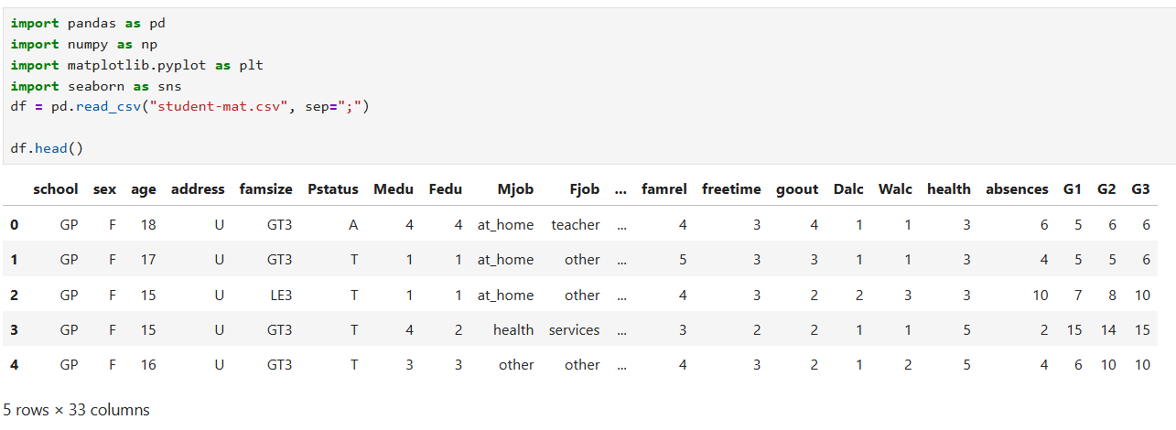
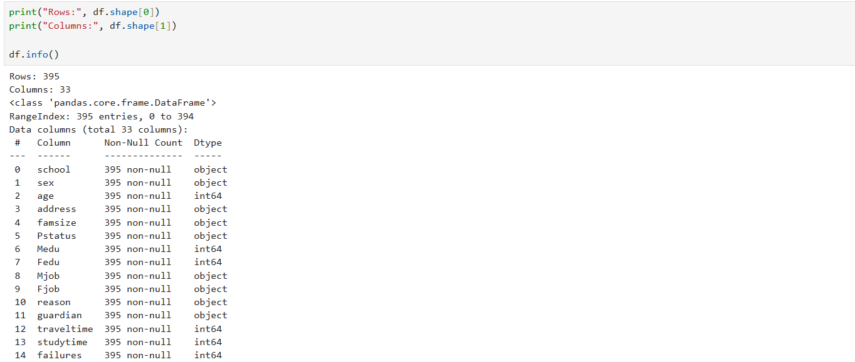
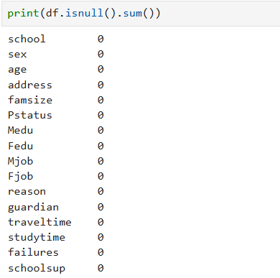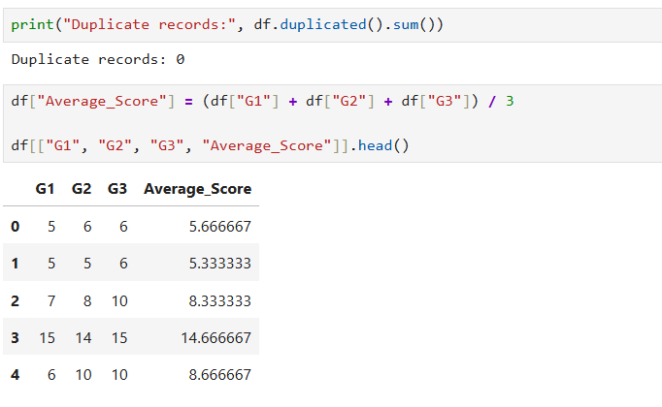
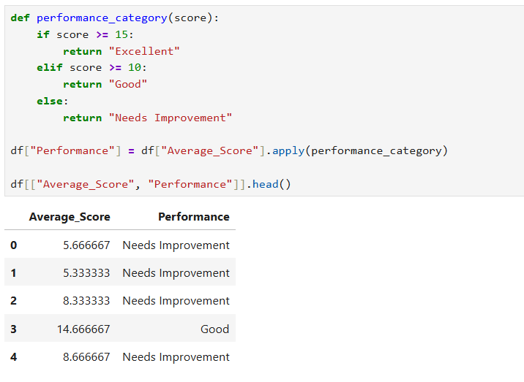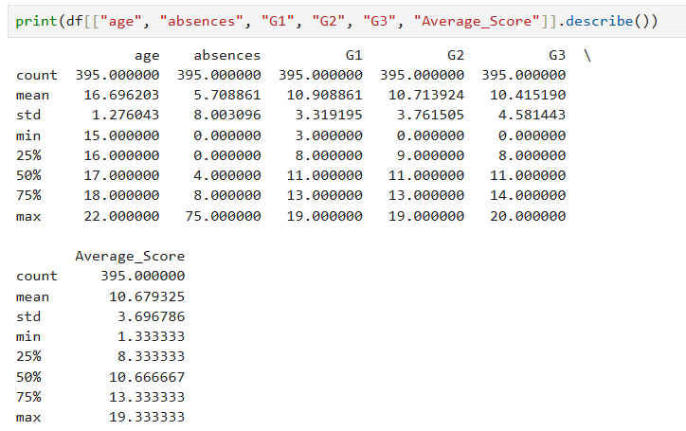
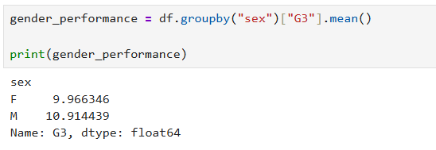
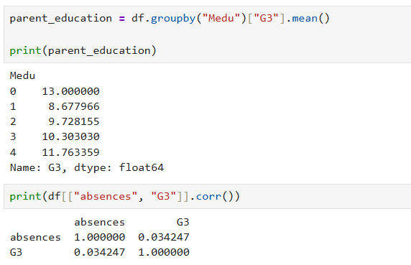
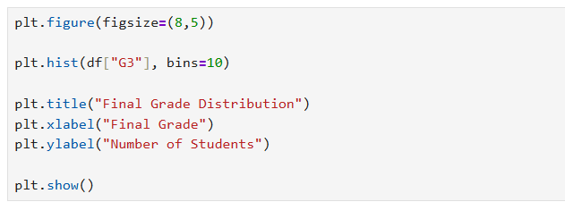
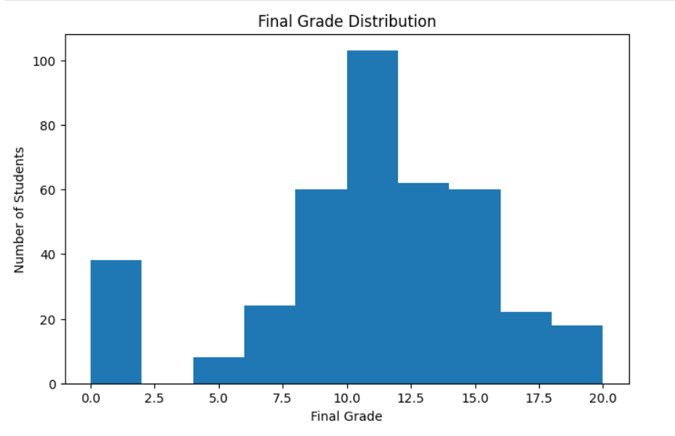
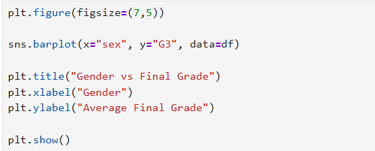
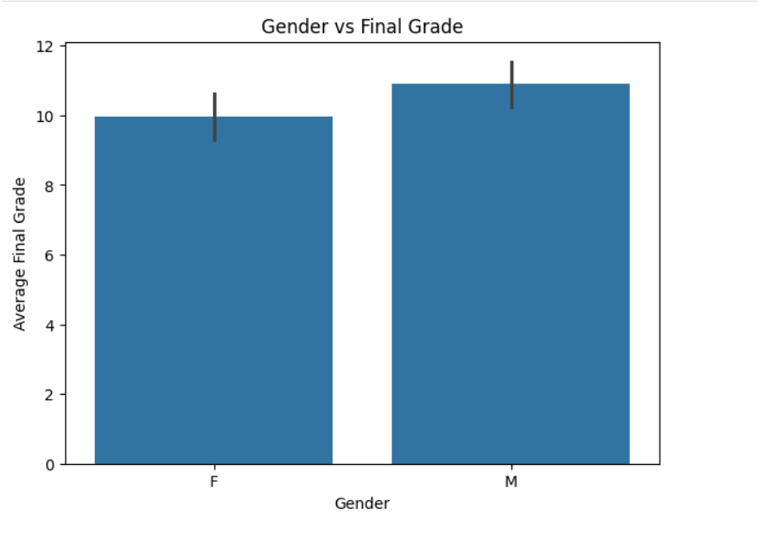
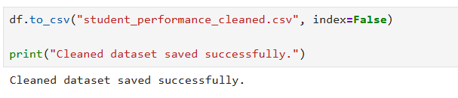
POWERBI PROCEDURE:
- Open Microsoft Power BI Desktop and select Home → Get Data → Text/CSV.
- Select the student_performance_cleaned.csv file generated using Python and click Load.
- Check the imported data and verify the columns such as Gender, Age, School, Parental Education, Absences, G1, G2, G3, Average Score, and Performance.
- Create Card visuals to display Total Students, Average Final Grade, Average Score, and Average Absences.
- Create a Column Chart to compare the average scores of G1, G2, and G3.
- Create a Bar Chart to analyze average final grade based on gender.
- Create a Column Chart to compare student performance between schools.
- Create a Donut Chart to show the distribution of students according to Performance categories.
- Create a Scatter Chart to analyze the relationship between absences and final grades.
- Create a Bar Chart to analyze the relationship between parental education and student performance.
- Add Slicers for Gender, School, Age, and Performance to make the dashboard interactive.
- Arrange all the visualizations neatly on a single dashboard page.
- Add the title “Student Academic Performance Analytics Dashboard”.
- Format the charts, titles, labels, and cards for better readability.
- Save the Power BI project as a .pbix file.
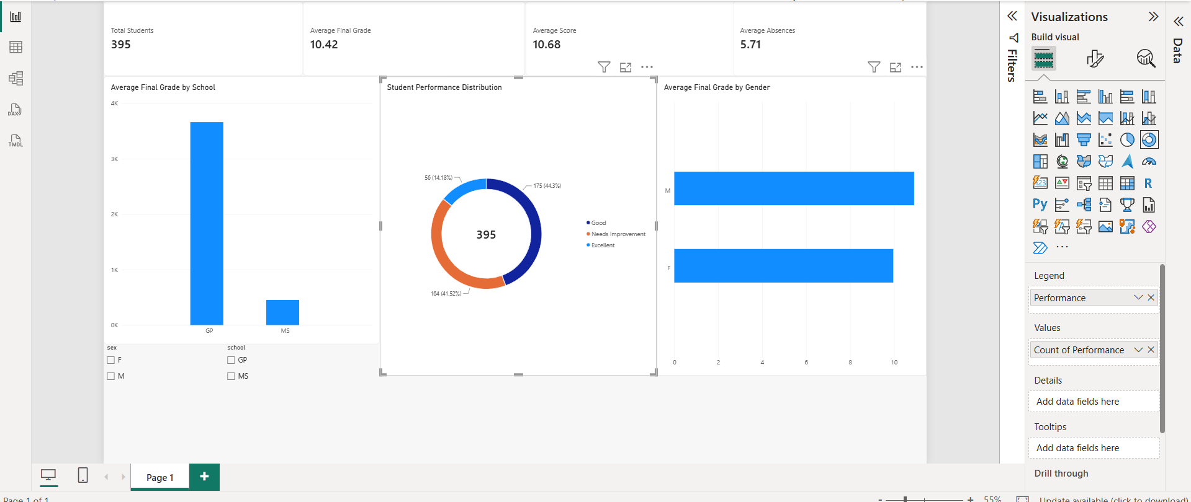

RESULT:
The student performance dataset was successfully cleaned and analyzed using Python, and an interactive Power BI dashboard was created. The project provided insights into student grades, absences, gender-wise performance, school-wise performance, and parental education. The dashboard helps in understanding student academic performance through simple and interactive visualizations.

